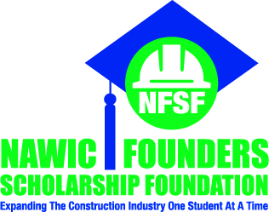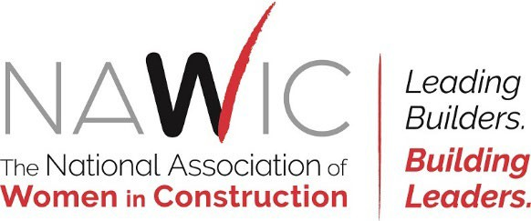

# *Insert Date*

Attn: Past Recipient of our Scholarship

# Subject: 2024- 2025 NAWIC Founder’s Scholarship

Dear Construction Trades Financial Aid Assistant,

The National Association of Women in Construction (NAWIC) is a non-profit association of women actively employed in the many facets of the construction industry, with more than 6,000 members in chapters throughout the United States.

Each year *(insert name of chapter / other donor),* in an effort to promote excellence in all aspects of the construction industry, is proud to offer scholarships to candidates (male or female) pursuing a career in the construction industry.

All who possess a commitment to obtaining an education leading to a degree through a course of study in construction are encouraged to review the scholarship guidelines, eligibility requirements and submit their application for consideration. Scholarship awards may be applied toward the cost of tuition and/or course expenses as selected by the recipient. The applicant has the ultimate responsibility to ensure the scholarship application is completed.

The dollar amount of scholarships awarded last year ranged from $1,000 to $7,500. Please submit all required documentation to NAWIC Founders’ Scholarship Foundation. The scholarship application can be found online at <https://nawic.org/nfsf-scholarships/> No need to apply for a specific scholarship award, by applying you are eligible to win any scholarship that is available to you based on preset criteria. **The application and any other required documentation must be in by February 28, 2025.**

If you have any questions, please feel free to contact me at *insert phone number* or by e-mail *insert e-mail address*.

Sincerely,

*Insert First Name, Last Name*

Scholarship Chair

NAWIC *Insert Chapter Name*